Sample

Procedure
THERAPEUTIC PRODUCT RECALL NOTIFICATION PROCEDURE

Definition / Description:
To ensure that all Therapeutic Product Recall Notifications, Safety Alerts and Quality Alerts are handled in a safe, consistent and timely manner across all areas of [HEALTH SERVICE]. To ensure that all Blood Product recalls are actioned immediately.
Personnel Able to Perform or Assist with Procedure:
- Clinical Products Manager.
- Director Logistics or nominated delegate.
- Logistics staff as directed by Director Logistics.
- Assistant Director of Nursing (ADON) In and After Hours. • Director Pharmacy or delegate.
Expected Outcomes:
- That all Therapeutic Product Recall Notifications, Safety Alerts and Quality Alerts are handled in a consistent and timely manner to minimise potential risk to staff, patients and visitors to
[HEALTH SERVICE].
- Blood product recalls are responded to appropriately.
- Suitable replacement items are obtained as soon as practicable and account credits are provided by suppliers as applicable.
- Documentation is maintained of all notifications and responses.
Equipment:
- Recall Health Registration and Login details.
- ‘Recalls / Safety Alerts and Product Quality Tracking System’ Excel spreadsheet located at [URL location].
Process Standards:
- The primary mechanism for generation of a Therapeutic Product Recall Notification is via GS1
Recall Health. The Clinical Products Manager is the Primary Contact at [HEALTH SERVICE] for Therapeutic Product Recalls from Recall Health.
- All Therapeutic Product Recall Notifications, Safety Alerts and Quality Alerts are to be forwarded to the Clinical Product Manager / Director Logistics regardless of source of notification and type of notification.
- The Clinical Products Manager will ensure:
−  −  −  − | Prompt action is taken to ensure that alerts and recalls are communicated to relevant managers and staff and where appropriate all affected items are located and quarantined from use.  [HEALTH SERVICE] response is appropriately coordinated, eg: return of the effected items to suppliers as per directions within recall notices.  The notification is entered to the ‘Recalls / Safety Alerts and Product Quality Tracking System’ Excel spreadsheet located at [HEALTH SERVICE URL]. This is to include actions taken in the return of items and either issuing of credit notes or replacement of items.  A file is maintained of all original notification paperwork.
©
RECALL HEALTH:
When an Initiating company selects [HEALTH SERVICE] as a Recipient for its Recall Notification and the Notification is issued by GS1 Recall Health, users with the User Role type of Receiver will be sent an email alert advising them that there is a notification waiting for their action in the GS1 Recall
Health portal.
To view the notification you must first log into GS1 Recall Health.
NOTE: Anyone can read and be forwarded the email, however only registered users will be able to log in to Recall Health to see the full details of the notification and record any notes/ actions against the notification.
USER ROLE RECEIVERS:
The following positions are registered as Receivers in Recall Health at [HEALTH SERVICE] and are able to log in and respond within the Recall Health Portal:
- Clinical Products Manager.
- Senior Procurement Officer.
- [HEALTH SERVICE] Biomedical Manager.
- Biomedical Engineer.
- Nurse Manager Theatre Suite.
- Nurse Unit Manager (NUM).
- NUM Theatre Suite.
- Director Pharmacy.
- Deputy Director Pharmacy.
Email Auto-forwarded from CPM:
The following positions are auto forwarded the Recall Health Email alert with no log in or response in Recall Health required:
- Director Logistics.
- Chief Executive Officer.
- [HEALTH SERVICE] Combined ADON.
LOCATING THE RECEIVED NOTIFICATION:
Login to GS1 Recall Health as a Recipient and click on Received Notifications. This will display a list of Notifications received by [HEALTH SERVICE].
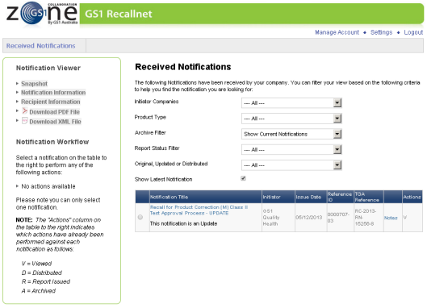
Use the Reference ID in the email alert to identify the received Notification.
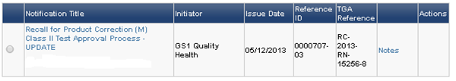
Click on the Notification Title to view the received Notification.
VIEWING THE RECEIVED NOTIFICATION:
The Notification Viewer screen will contain details of the Received Notification as displayed below.
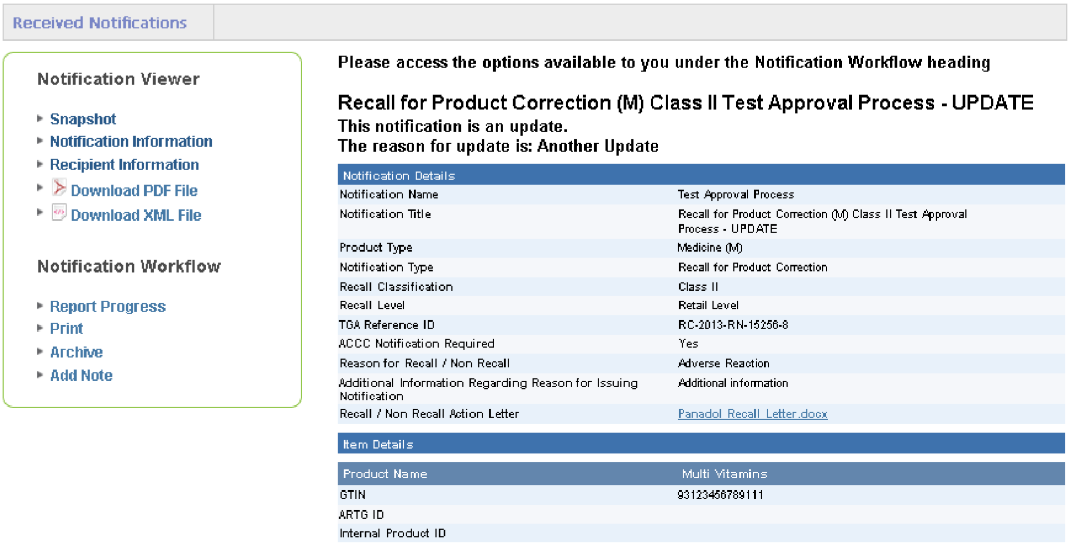
Use the links under the Notification Viewer section to view the different sections of information relating to the notification:
- Snapshot.
- Notification Information.
- Recipient Information.
GS1 Recall Health allows [HEALTH SERVICE] to download and view the notification in PDF - locate the links under the Notification Viewer section.
The Notification Workflow section allows several functions to be performed for the Notification:
- Report Progress.
- Print.
- Archive.
- Add Note.
Only registered users can update the notification with actions / notes and see the full details of the notification.
ON FORWARDING:
On forwarding is the process of forwarding the email and/or the full details of the notification
(downloaded from Recall Health) to others within [HEALTH SERVICE] who need to know about the notification.
There is no need to do this for any users who are set up as “Receivers”. At [HEALTH SERVICE] the Clinical Products Manager is responsible for on forwarding notifications.
Distributing is the process of forwarding the notification to external partners in the supply chain, other Hospitals or Health Services that [HEALTH SERVICE] has provided the affected product to. For example, medication purchased by [HEALTH SERVICE] for smaller Health Services. [HEALTH SERVICE] will receive the notification, assess who has been supplied the affected product and distribute the notification to that Health Service. In general only the Pharmacy Department or Logistics are required to distribute notifications for [HEALTH SERVICE].
Reporting Progress:
Receivers are able to report on the progress of the recall back to the sponsor using this option on the Notification Workflow. This option can be used multiple times during the life cycle of the recall to enter progress information.
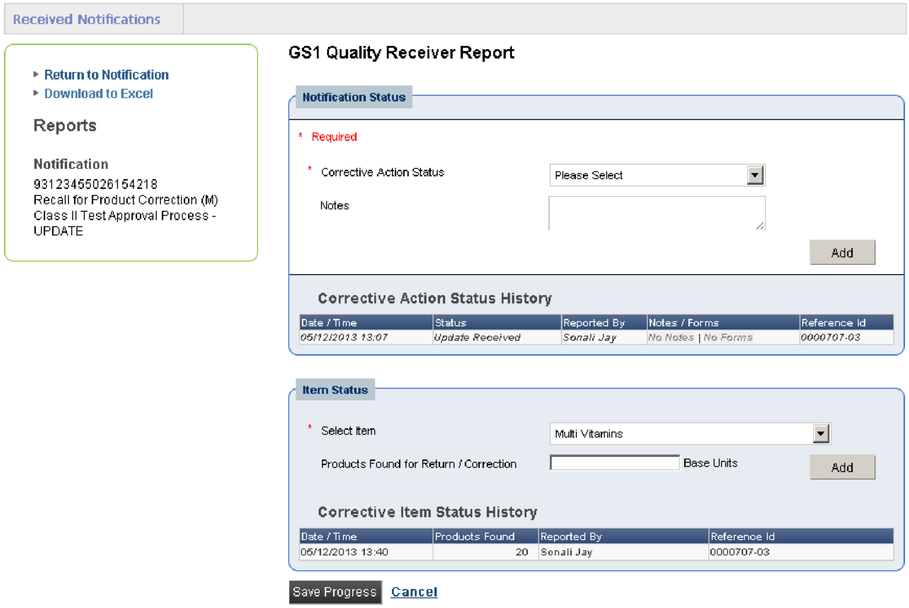
Click on the Report Progress link. The following screen will be displayed:
To report on the Notification Status, select a Corrective Action Status from the drop down list provided. Enter relevant information on the Notes section and select Add. The information will now be displayed under Corrective Action Status History as below.
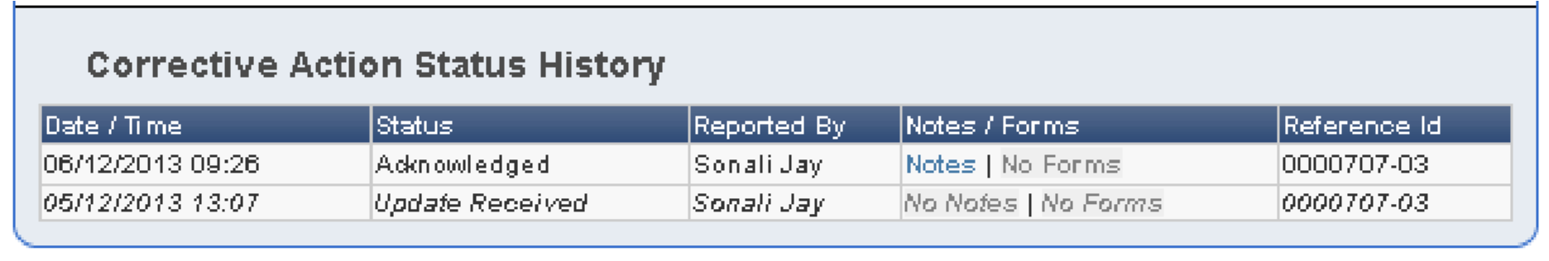
To report on the status of items within the Notification, select the applicable item from the drop down list. This list will contain all the items that are included in the Notification.
Enter the number of products and select Add. The information will be displayed under the Corrective Item Status History as below.
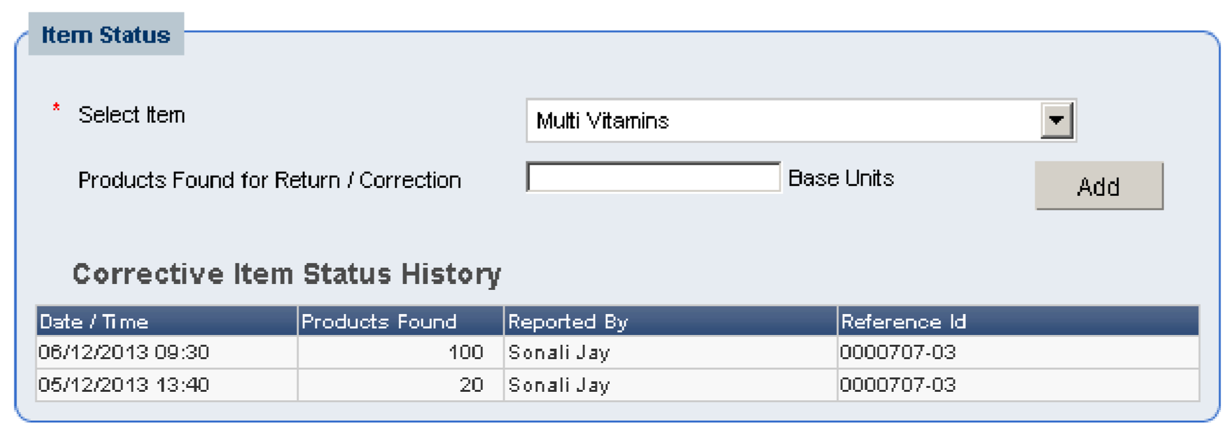
Select Save Progress to save the entered information. This information will now be visible to the initiating company (sponsor) for status reporting.
PRINTING A NOTIFICATION:
Selecting the Print option on the Notification Workflow to print a copy of the Notification.
ARCHIVING A NOTIFICATION:
A Received Notification can be archived once access is no longer required. In the Notification Viewer screen of a Received Notification an Archive link is available under the Notification Actions section. Click on Archive and follow the prompts to archive the Received Notification. The archived Notification is able to be retrieved.
For further information on use of Recall Health see Healthcare Recall Health User Guide available at: https://recallnet.gs1au.org
BLOOD PRODUCTS:
Recall Health does not manage Blood and Blood Product recalls:
- The laboratory is responsible for managing recalls and ensuring traceability of blood and blood products issued by the Laboratory.
- The Health Service is responsible for managing recalls and ensuring traceability of blood and blood products issued through both the transfusion laboratory and also directly through to the Hospital(s) by the ARCBS or other manufacturer.
- At [HEALTH SERVICE] all blood products are ordered and issued from the Laboratory.
Recall notifications for blood products for positive bacterial screening and donor-initiated are considered urgent. At any point recalls may be initiated based on:
- Initial machine positive bacterial screening results.
- Quarantines.
- Look backs.
- Look back for donor-related issues - both recent and historical.
Rationale:
In the compromised patient the administration of a recalled product may have serious consequences.
Notification to the treating Medical Officer (MO) is urgent to ensure the patient is examined and treatment is initiated where required.
ESCALATION:
If it is unclear what action to be taken with any Therapeutic Product Recall, including Blood products, the appropriate escalation / clarification pathways are:
Blood Products:
ADON In and Out of Hours. Phone: 0428 105 997
Clinical Items:
Operational Director Surgical Services.
Operational Director Critical Care and Emergency Departments DDON.
Operational Director Acute Services.
Operational Director Women’s and Children’s Services DDON.
Pharmacy Items:
Director Pharmacy or delegate.
Other Items:
Executive Director Corporate Services (EDCS).
Director Quality and Clinical Governance (DQ&CG). Director of Infrastructure.
Reporting:
All documentation and status of recalls is to be available for reporting and audit purposes. Such requests are to be placed via the EDCS.
Annexes: | 1. Process Flow: Therapeutic Products Recall.
Related [HEALTH SERVICE] Documents: | Therapeutic Product Recall Notification Policy (POL0478).  Logistics Goods Return Policy (POL0621).  Logistics Goods Return Procedure (PRO1281).  Logistics Goods Return Form.
Accreditation Standards: | EQuIP National Standard 1.2  EQuIP National Standard 7.1  EQuIP National Standard 15.16.1
Other Relevant Information:  References: | Healthcare Recall Health User Guide available at:  https://recallnet.gs1au.org
Contact Point: | Director Logistics.
In consultation with:
TITLE / POSITION
THIS SECTION FOR QUALITY & CLINICAL GOVERNANCE OFFICE USE ONLY
Approved by Executive / Delegate: | Date Approved: | SharePoint Location:
Executive Director of Finance & Corporate  Support | 5 June 2014 | Procedures….
Responsible Department: | Date for Review: | Linked Documents:
Director of Logistics | 5 June 2017
Version No: | Original Approval Date: | Previously Named As:
2 | 5 September 2011 | Product Recall, Safety Alert and Product Quality Alerts Notification Procedure  (PRO1159)

ANNEX 1

Process Flow
THERAPEUTIC PRODUCTS RECALL
Other

Notification
s

Enter details to:
Recalls / Safety Alerts and
Product Quality Tracking
System.
Located at:
[
HEALTH
SERVICE URL
]

Take appropriate action to ensure
a
ffected items are withdrawn from
service

Clarification /
Escalation Guide

Cli
nical Items

•
CPM
•
Director Logistics
•
Operational Directors
Pharmacy Items

•
Director Pharmacy
Other Items

•
Exec
utive Director
Corporate Services
•
Dir
ector

Quality &
Clinical Governance
•
Dir
ector

Infrastructure
CPM arrange r
eturn
of
items to supplier

Or

Take

action as directed by supplier

Document action/outcome in:
Recalls / Safety Alerts and Product
Quality Tracking System

Located:
[
HEALTH SERVICE URL
]

Maintain original paperwork into CPM
hardcopy file
Pharmacy

to
distribute
notification
to
identified
external partners

by email

Blood product
has been
administered

ADON to ensure
Medical Officer
advised

ADON

Notified

Liaise

with
Laboratory

and

advise CPM

All
Blood
products
Blood product
has
not

been
administered

Medical Officer to take
action as directed by
supplier, follow up care
and counsel patient
where required
.

RECALL
HEALTH

Notification
Email notification
sent
to
Receivers:

•
Clinical Product Manager
•
Senior Procurement
•
Biomedical Manager
•
Biomedical Engineer
•
Nurse Manager Theatre Suite

•
NUM Theatre Suite
•
Director Pharmacy
•
Deputy Director Pharmacy
Clinical Products
Manager

Receivers
to acknowledge and
respond in Recall
Health

ADON SMS

N
otification
Alert
ADON
(
After hours only)
Email auto forwarded to:
Director Logistics
CEO
[
HEALTH SERVICE
]

Combined ADONs

